Ayan Basu (EID: ab73287)

Dr. Yerraballi - Unique #17070

EE319K - Intro. To Emb. Sys.

02 February 2021

***Lab 1 - Digital Logic on TM4C123***

***Part B - Flowchart***

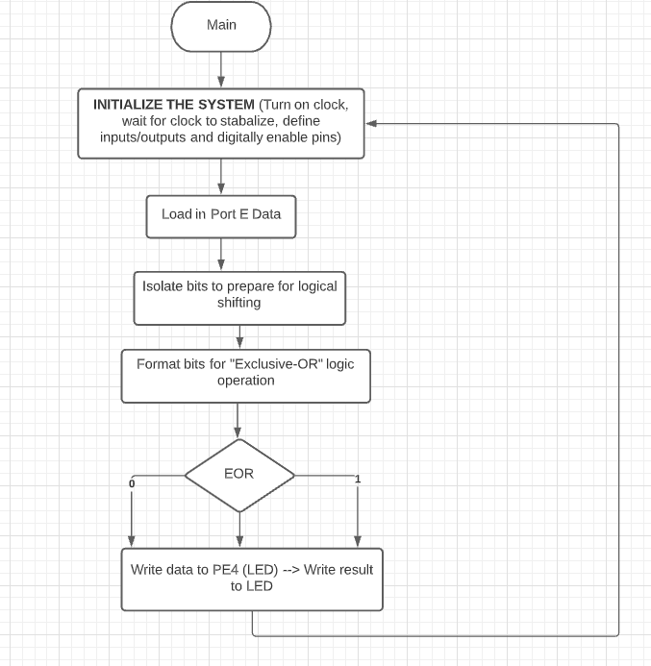

***Part C - Pseudocode***

Start -Activate clock for port (Read/Modify/Write) (E = 1)

-Wait for clock to stabilize

-Define inputs and outputs

-Digitally enable PE0, PE1, PE2, PE4 pins

-Make PE0, PE1, PE2 (switch) pins as input

-Make PE4 (LED) pin as output

Loop -Read input from switch

-Isolate and format bits for logical shifting

-Display output (0 or 1 → LED ON or OFF)

-Branch Loop

***Part D - Results***

